**CLOUD-ENABLED BLOOD BANKING MANAGEMENT SYSTEM**

**A Project Report Submitted by:**

**ELUGOTI SHARON 001112693**

**RENUKA KANKANALA 001075408**

**Acknowledgement**

We would like to express my special thanks of gratitude to my Professor Umama Tasnim who gave me the golden opportunity to do this wonderful project on the topic Blood Banking Management System , which also helped me in doing a lot of Research and We came to know about so many new things I am really thankful to them.

Secondly, we would also like to thank our friends who helped me a lot in finalizing this project within the limited time frame.

**ABSTRACT**

The process of managing the blood bank that is received from the blood donation events needs a proper and systematic management. The blood bank must be handled with care. The development of Blood Bank Management System (BBMS) is proposed to provide a management functional to the blood bank in order to handle the blood bag.

The technology platform in implementing this system uses JAVA programming environment and MySQL for SQL databases. The system keeps the record of all the donors, recipients, blood donation programs, and rejected bloods. For internal works and activities intranet is used and for interaction with public internet is used. This system also has the ability to keep track of the donor's donation records and the blood stock in the blood bank. This project intends to computerize the blood and donor management system in a blood bank in order to improve the record management efficiency due to the growing size of records of data.

# Table of Contents

**Title page Acknowledgement Abstract**

* **Introduction**
* **Materials And Methods**
* **Project Implementation (Output)**
* **Conclusion**
* **Bibliography**

**Introduction**

At present, the public can only know about the blood donation events through conventional media means such as radio, newspaper or television advertisements. There is no information regarding the blood donation programs available on any of the portals. The current system that is used by the blood bank is a manual system.

With the manual system, there are problems in managing the donors' records. The records of the donor might not be kept safely and there might be missing of the donor's records due to human error or disasters. Besides that, errors might occur when the staff keeps more than one record for the same donor.

There is also no centralized database used to keep the donors' records. Each bank has their own records of donors. If a donor makes a donation in a different hospital, no previous records can be traced except if the donor brings along the donation certificate.

Hence, the donor is considered to be a first-timer if they make blood donation in a new place. Without an automated management system, there are also problems in keeping track of the actual amount of each and every blood type in the blood bank. In addition, there is also no alert available when the blood quantity is below its par level or when the blood in the bank has expired.

## Hardware/Software Requisites –

1. Operating System: Windows
2. Database Management System: MySQL
3. Programming Language: JAVA
4. Development Environment -NetBeans IDE
5. 32/64 – bit processor
6. Frameworks used -Swing package (JAVA)

## Materials And Methods

**Workflow of the Software**

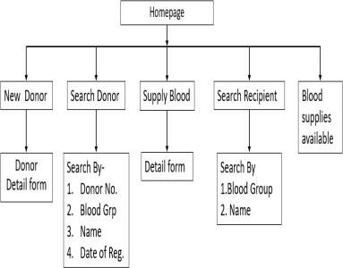

# Algorithms to be used :

**Insertion in database**

1. Take input from the user from textbox 2. Convert into text
2. Select the table to insert values.
3. Insert value into respective columns.
4. Exit

**Retrieval from Database**

1. Select the table to retrieve values from.
2. Search for the column
3. Search for the value to be retrieved.
4. Print the value.
5. Exit

**Bibliography**

* wikipedia.org
* google.com
* geeksforgeeks.com
* Documentation of Swing Package About.com

# Conclusion

Our Project is a humble venture to satisfy the needs in a blood bank to manage their stock, inventory. Several user-friendly coding have also been adopted. This package shall prove to be a powerful package in satisfying all requirements of blood bank. The objective of software planning is to provide a frame work that enables the manager to make reasonable estimates made within a limited time frame at beginning of software project and should be updated regularly as project progresses.